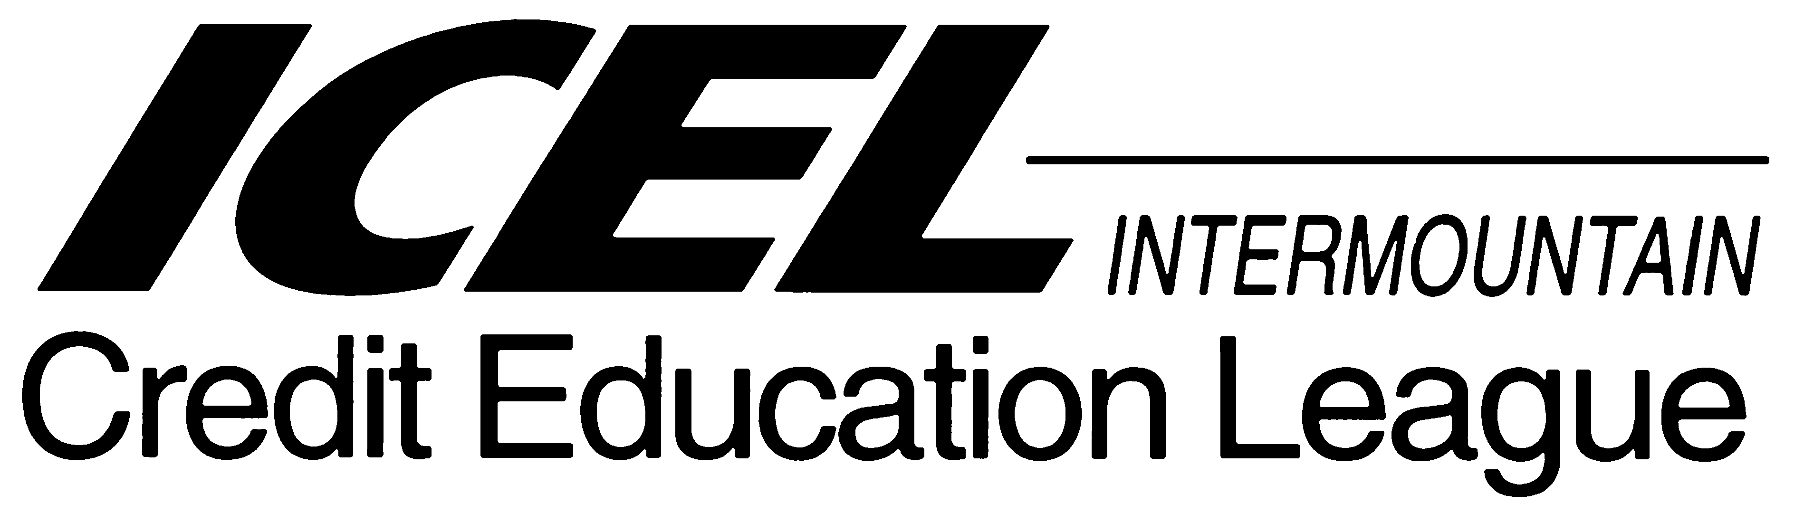

Application for Membership
Date:
I hereby apply for membership in the Intermountain Credit Education League (ICEL) and agree to pay an initial enrollment fee of $10.00 and dues, which are currently $80.00 annually – billed on a quarterly basis ($20.00 per quarter). I agree to abide by the organizational bylaws. Payment is due upon receipt of statement and payable in Salt Lake County, Utah. If my account must be placed for collection, I agree to pay interest and the rate of 1/5% per month and 33% for attorney fees plus court costs.
I/We understand that this membership continues from year to year at the prevailing rate unless notice of resignation is given in writing to NACM/ICEL.
Name: Title:
Company: NACM Member No.
Mailing Address: Phone #.
Street Address: Fax #.
City: State: Zip:
Email: Years with Co. Years in Credit:
Home Address: Home Phone:
City: State: Zip:
Bill my company Bill me personally

Signature: ___________________________________________
All information given above is used only for your personal file and is held in strict confidence.
Return completed form to: Holly Van Wagoner, Education Dept. NACM BCS, 5710 S. Green Street, Murray, UT 84123 or Email: holly@nacmint.com.

